

**PURBANCHAL UNIVERSITY**

**Biratnagar, Nepal**

**KIST College of Information and Technology**

**1st Semester Project**

**On**

**“STUDENT COUNCIL VOTING SYSTEM”**

In the partial fulfillment for the requirement of the 1st Semester Project-I ()in the completion of Bachelor of Information Technology (BIT) degree at KIST college of Information Technology, under Purbanchal University.

**Submitted by: Submitted to:**

**Rohan Rana Magar - 4735 Purbanchal University**

**Kushal Amatya - 4726**

**Anurag Karki - 4734**

**Prashansa Sunuwar - 4713**

**Date:**

**Acknowledgement**

We take this opportunity to express our profound application and unfathomable regards to the Information Technology (IT) department for this commendable guidance, monitoring and constant encouragement throughout the course of this project. The help and guidance given by shall carry us the long way, in the journey in which we are about to commence.

We would like to express our deepest appreciation to all those who provided us the possibility to complete this project.  A special gratitude we give to our project manager, **Mr.Prawesh Dhungana** and coordinator **Mr. Deepak Khadka** whose contribution in stimulating suggestions and encouragement helped us to coordinate our project in various stages. We are grateful to all KIST members for providing the valuable suggestion and support which helped us a lot in our project work.

Finally, we would also like to express our special thanks of gratitude to **Purbanchal University** who gave us the golden opportunity to do this wonderful project. This project helped us in doing a lot of research and we came to know about so many new things we are really thankful.

We hope our university will accept out attempt as a successful project.

**Student’s Declaration**

We the students declare that the project report is based on our own work carried out during the course of our study under the supervision of **Mr. Prawesh Dhungana.** We assert the statements made and conclusions drawn are an outcome of our research work.

Furthermore, we certify that this project submitted is our original work and has never been submitted in any institution for any other titles or awards.

|  |  |  |
| --- | --- | --- |
| S.N | NAME | ID No |
| 1 | **Rohan Rana Magar** | **4735** |
| 2 | **Kushal Amatya** | **4726** |
| 3 | **Anurag Karki** | **4734** |
| 4 | **Prashansa Sunuwar** | **4713** |

**CERTIFICATE BY THE EXAMINERS**

This is to certify that the project report entitled **“Student council Voting System”** which is developed by **Rohan Rana Magar (4735), Kushal Amatya (4726), Anurag Karki (4734), Prashansa Sunuwar (4713),** students of **KIST College of Information and Technology** of the **Purbanchal University** during the year 2021. The project has been approved and accepted as it satisfied all the requirements to the respect of project work.

………………… ………………….

Internal Examiner External Examiner

Name: Name:

Designation: Designation:

**To whom it may concern**

This is to certify that **Mr. Rohan Rana Magar (4735), Mr. Kushal Amatya (4726), Mr. Anurag Karki (4734) and Mr. Prashansa Sunuwar (4713),** of Bachelor in Information Technology (BIT) has studied as per the curriculum of BIT 1st semester and completed the project entitled **“Student Council Voting System”.** This project was carried out under the supervision as per guidelines provided by **Purbanchal University** and certified as per the students declaration that project **“Student Council Voting System”** was completed to the full satisfaction and in accordance with the specifications of the project.

Course Semester: 1st semester

Subject: Project I

Subject code:

…………………….

Deepak Khadka

Program Coordnator

**Documentation**

Student Council Voting System

**Table of contents**

**BACKGROUND**……………………………………………………………..0-3

Abstract of the project

Introduction

Objective of the project

Future Implementation for the project

**SYSTEM REQUIRED**………………………………………………………..4

Minimum requirements

Recommended requirements

**SYSTEM DESIGN**………………………………………………………....5-13

Algorithm

Flowchart

**Use case diagram of the project**…………………….……………………...14

**Snapshots of the project**………………………………………………….15-22

**Source Code**………………………………………………………………...23-39

**Background**

**Abstract of the project**

The **“Student Council Voting System”** project aims to develop software where user can cast their votes to the candidates and choose their leaders. Also being an administrator of the software, details of the users who chose their leaders are kept confidentially.

This project is developed using C-programming language. It is meant for selecting the candidates as their future leaders according to the votes count and recording of the details of the voters. We have mainly focused on the term where only administrator can see the details of the voters using the administration password.

**1**

**Introduction**

The projects **“Student Council Voting System”** is a system that manages the votes count, leading candidates and the details of the voters. This system helps in storing the vote count of the candidates and showing the details of the voters in simple manner, only to the administration. This project has limited contents like **Cast vote, Show vote counts, Guess vote, Show lead candidates, Admin login.** These are the contents which fulfill our system project. This projects can be used during the election anywhere due to its flexibility. With the help of this project, the voters can vote easily just by pressing the keys. Also, this system records and stores the details of the voters which can only be accessed by the admin using a passcode. Due to this function, details of the voters are kept confidential. So this system is easy to use and works effectively anywhere anytime.

**2**

**Objective of the project**

* To record and store the votes count
* To show the future leading candidate
* To store the details of the voters
* To access the information of the voter only by admin in need

**Future Implementation of the project**

* Biometric security implementation
* Nationwide online voting system

**3**

**System required**

**MINIMUM REQUIREMENTS**

**HARDWARE**

* PC with Pentium II Processor
* 32 MB of RAM
* Black and White Monitor
* Hard disk with at least 20MB of free space

**SOFTWARE**

* OS Windows (Windows XP)

**RECOMMENDED REQUIREMENTS**

**HARDWARE**

* PC with i3 Processor
* 100MB of RAM
* LCD Monitor
* Hard Disk with at least 100 MB of space

**SOFTWARE**

* OS Windows (Windows 7)

**4**

**System design**

**Algorithm**

**Algorithm for main**

Step 1: Start.

Step 2: Initiate intro function.

Step 3: Initialize a variable.

Step 4: Display Main Menu having options:

* Cast your vote.
* Show total Vote Count.
* Guess who is going to win the voting.
* Show Leading Candidate.
* Press 5 if you are the school administration.
* Exit

Step 5: Get a choice and go to the chosen case.

Step 6: If user enters invalid choice then go to default case and display Please Enter correct choice.

Step 7: If choice is Exit go to Step 8 else go to Step 4.

Step 8: Stop.

**Algorithm for cast vote menu**

Step 1: Start

Step 2: Create a data file **Voter.dat** in append mode.

Step 3: Get Name, Grade, ID number and Candidate Chosen.

Step 4: Store all variable in data file.

**5**

Step 5: Initialize vote counter for each candidate.

Step 6: If Candidate chosen is 1 then increase counter1 by 1 Elseif Candidate chosen is 2 then increase counter2 by 1 Elseif Candidate chosen is 3 then increase counter3 by 1 Elseif Candidate chosen is 4 then increase counter4 by 1.

Step 7: Close the data file **Voter.dat.**

Step 8: Stop.

**Algorithm for showing vote count**

Step 1: Start.

Step 2: Display Candidate1 name and counter1.

Step 3: Display Candidate2 name and counter2.

Step 4: Display Candidate3 name and counter3.

Step 5: Display Candidate4 name and counter4.

Step 6: Stop.

**Algorithm for guessing vote**

Step 1: Start.

Step 2: Initialize guessno as a variable.

Step 3: Get guessno.

Step 4: Create an array having counters as its element.

Step 5: Swap the counters inside the array in descending order and get the first element of the array after swap.

Step 6: If guessno is equal to the first element of the array, display Candidate is in the Lead position else display Candidate is not in the lead position.

Step 7: Stop.

**6**

**Algorithm for leading candidate**

Step 1: Start.

Step 2:Get counters for each candidate.

Step 3: If counter1>counter2>counter3>counter4 display Candidate1 is the Leading Candidate and goto Step 7.

Step 4: If counter2>counter1>counter3>counter4 display Candidate2 is the Leading Candidate and goto Step 7.

Step 5: If counter3>counter2>counter1>counter4 display Candidate3 is the Leading Candidate and goto Step 7.

Step 6: If counter4>counter2>counter3>counter1 display Candidate4 is the Leading Candidate and goto Step 7.

Step 7: Stop

**Algorithm for Admin Panel**

Step 1: Start.

Step 2: Initialize showvote as a variable.

Step 3: Get showvote from admin.

Step 4: Open the file Voter.dat in read only mode.

Step 5: Retrieve Name, Grade, ID number and Candidate Chosen from file and store them.

Step 6: If showvote is equal to Candidate Chosen display all Names, Grades and ID numbers that have the similar Candidate Chosen.

Step 7: Close the data file Voter.dat.

Step 8: Stop.

**7**

**Flowchart**

**Flowchart of Main Menu**

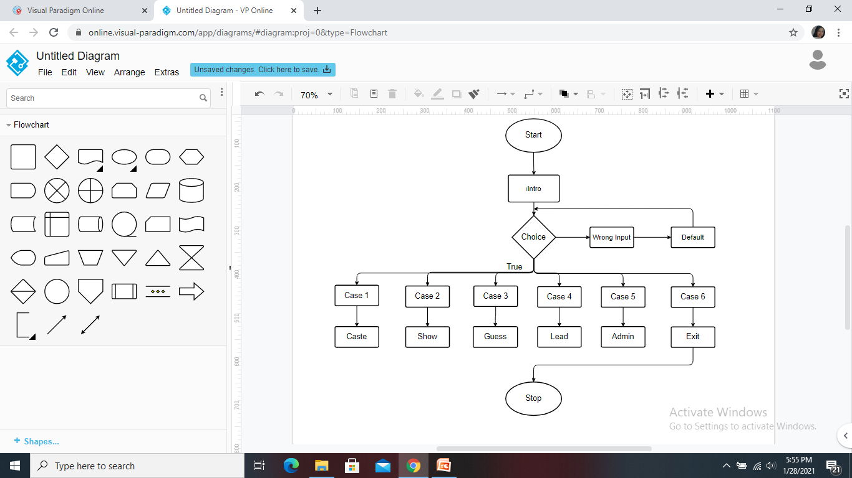

**8**

**Flowchart of Cast Vote**

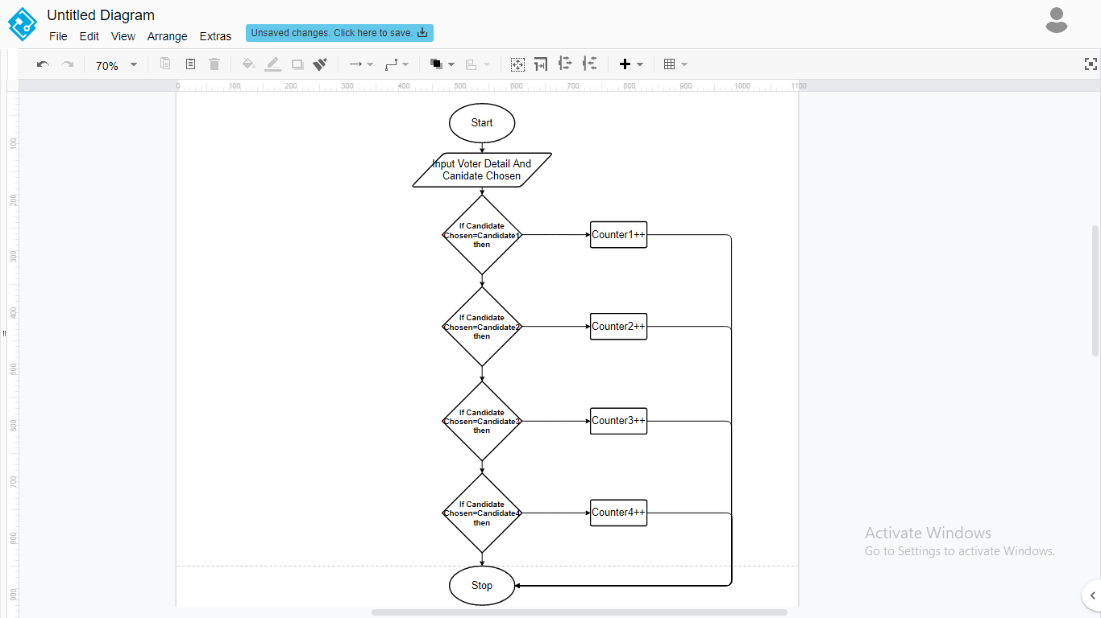

**9**

**Flowchart of Showing Votes count**

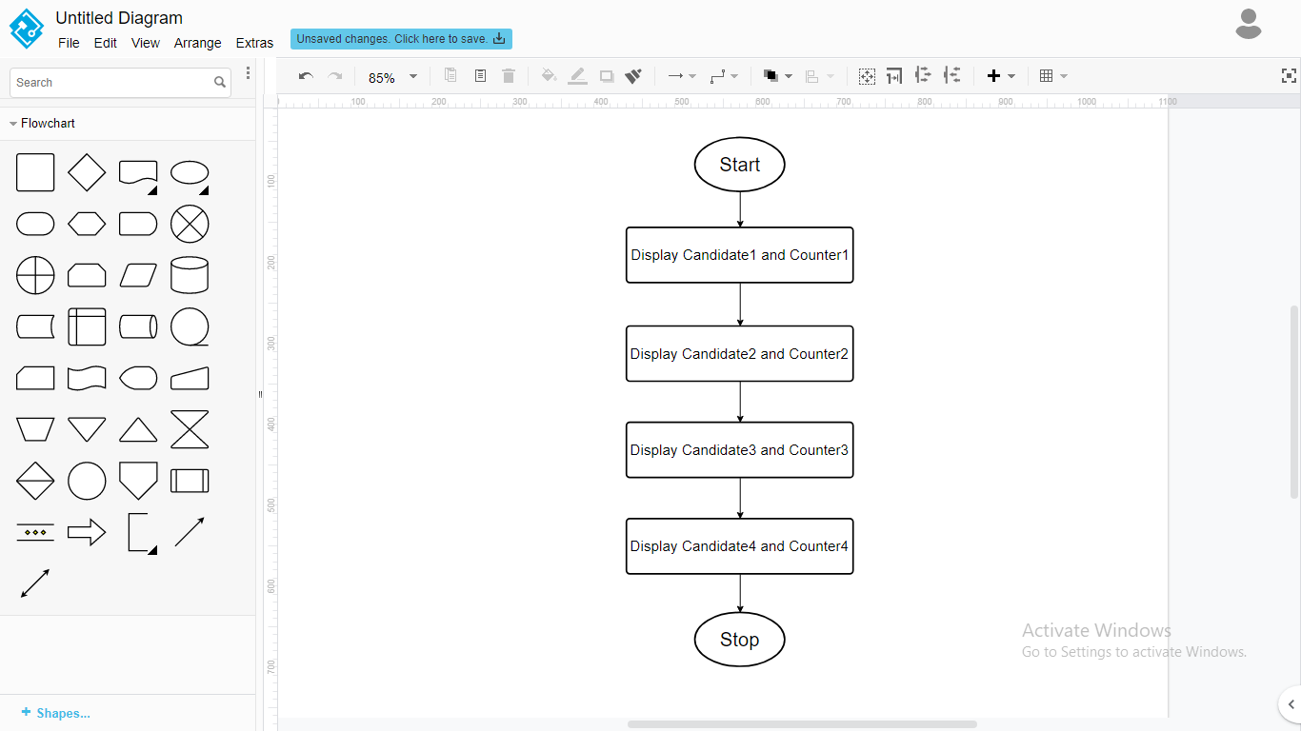

**10**

**Flowchart of Guess leader**

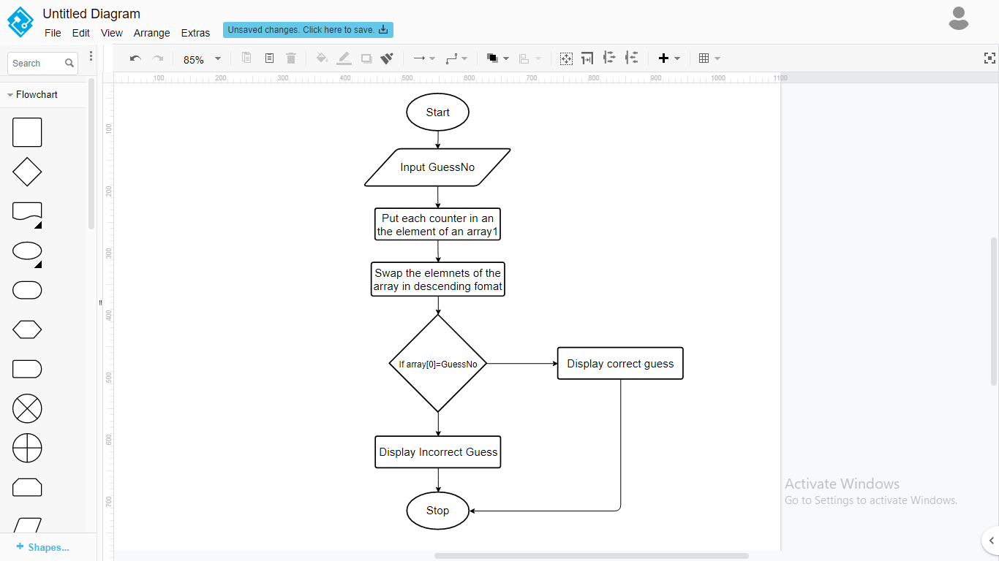

**11**

**Flowchart of Lead Count**

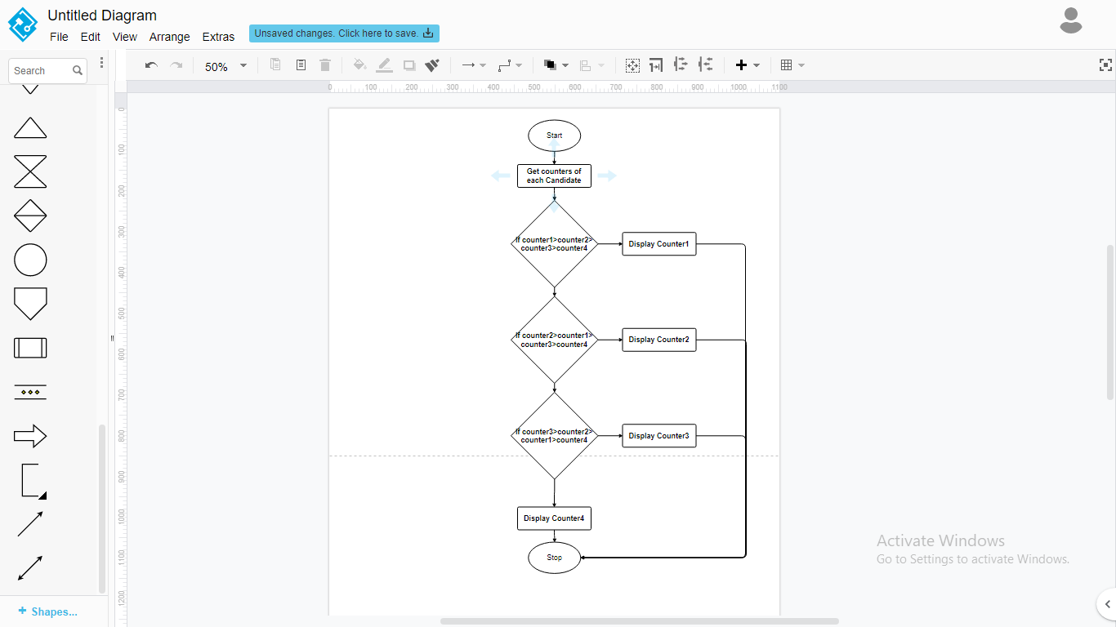

**12**

**Flowchart for Admin Panel**

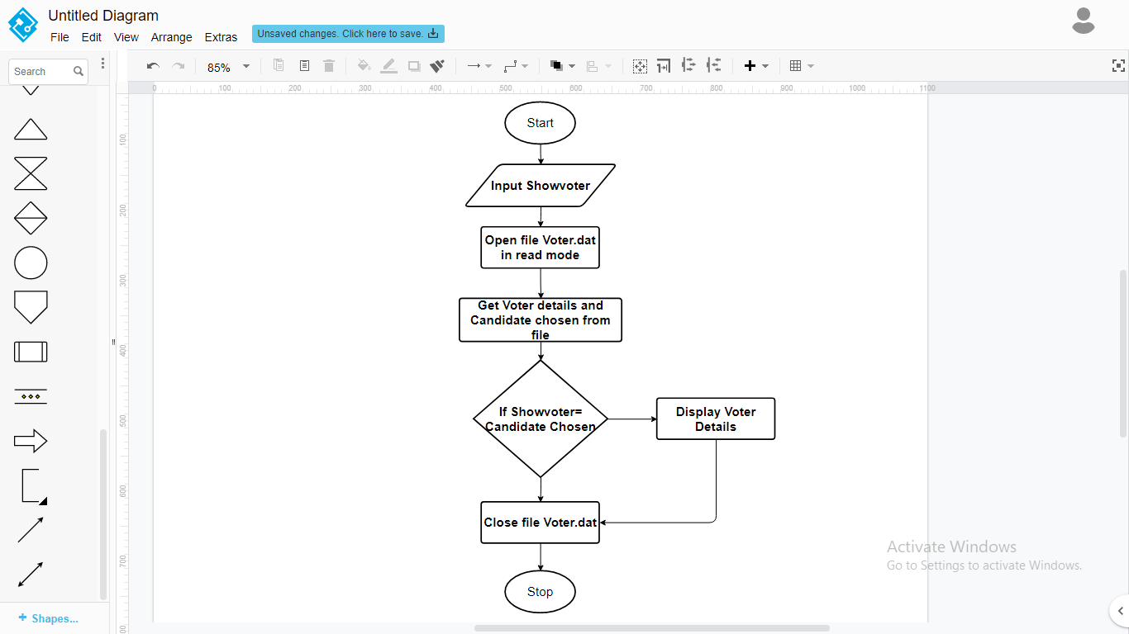

**13**

**Use case diagram of the project**

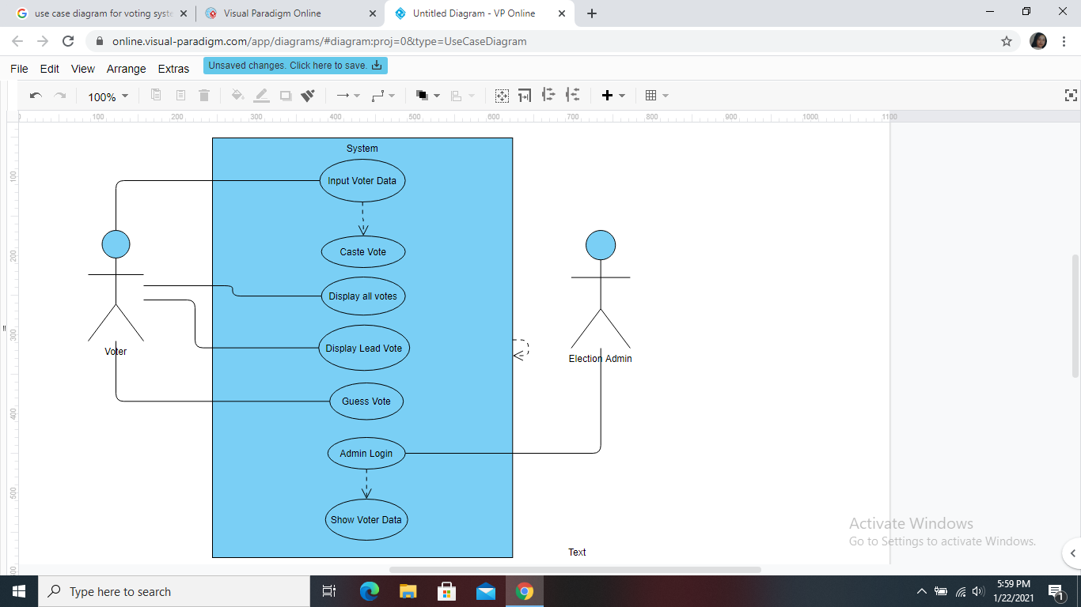

**14**

**Snapshots of the project**

**Intro:**

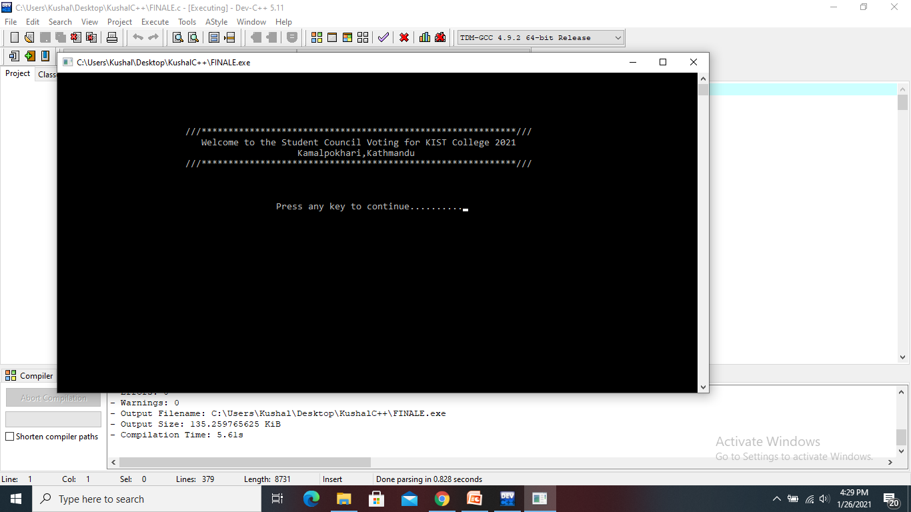

**15**

**Main menu:**

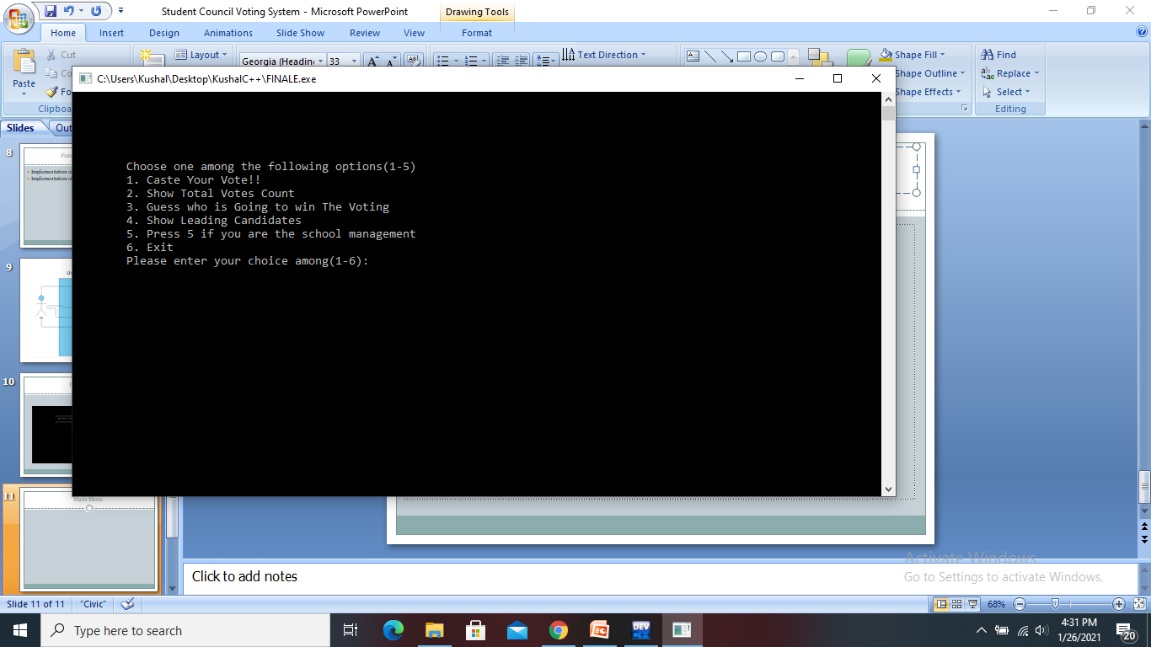

**16**

**Casting vote:**

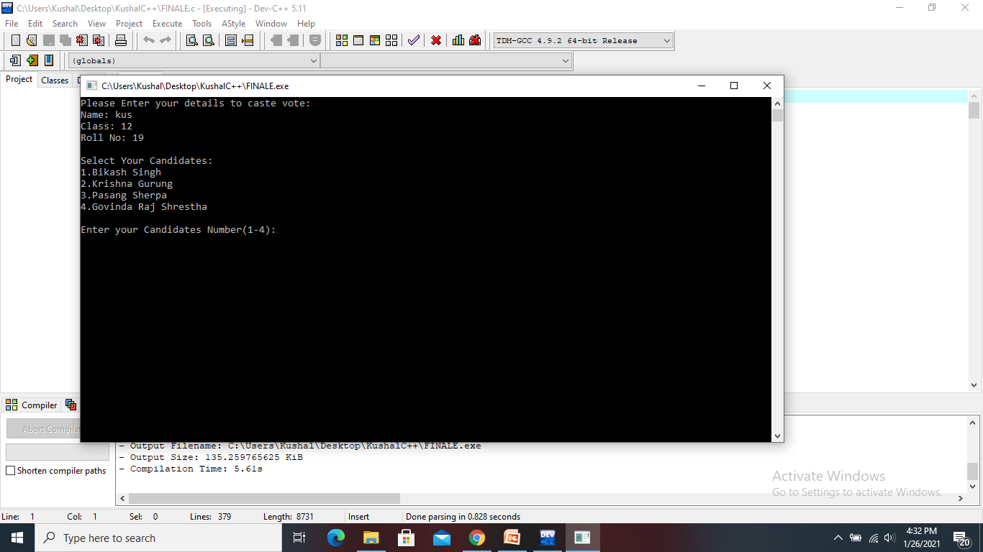

**17**

**Total votes count:**

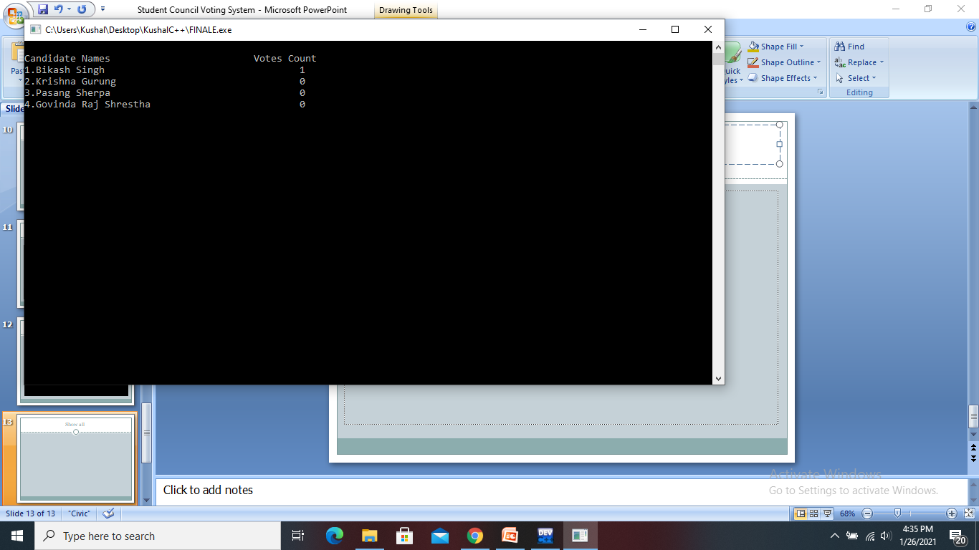

**18**

**Guessing the future leader:**

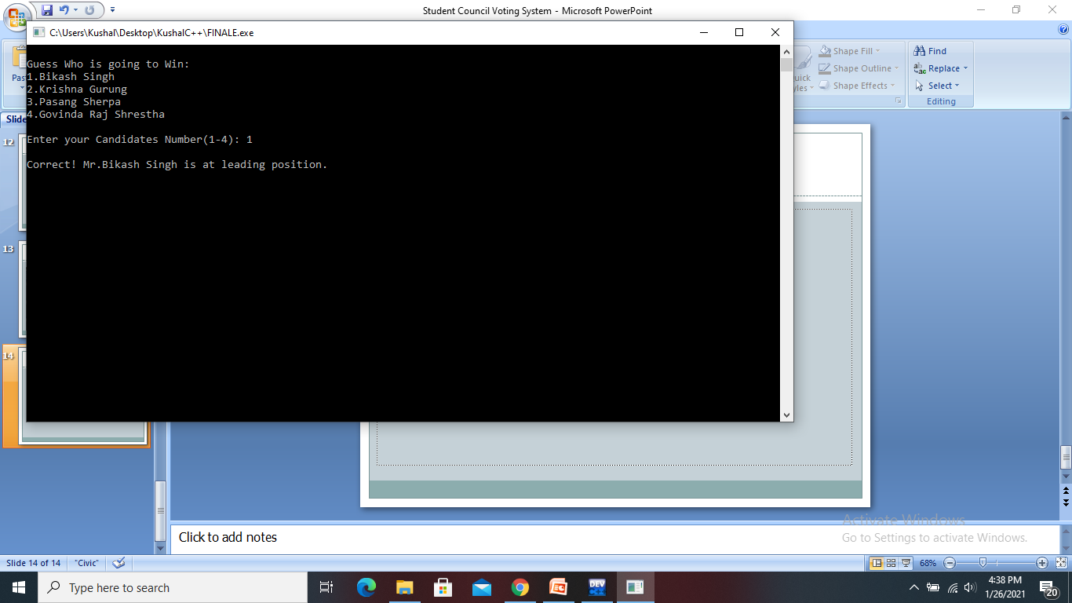

**19**

**Showing leading candidate:**

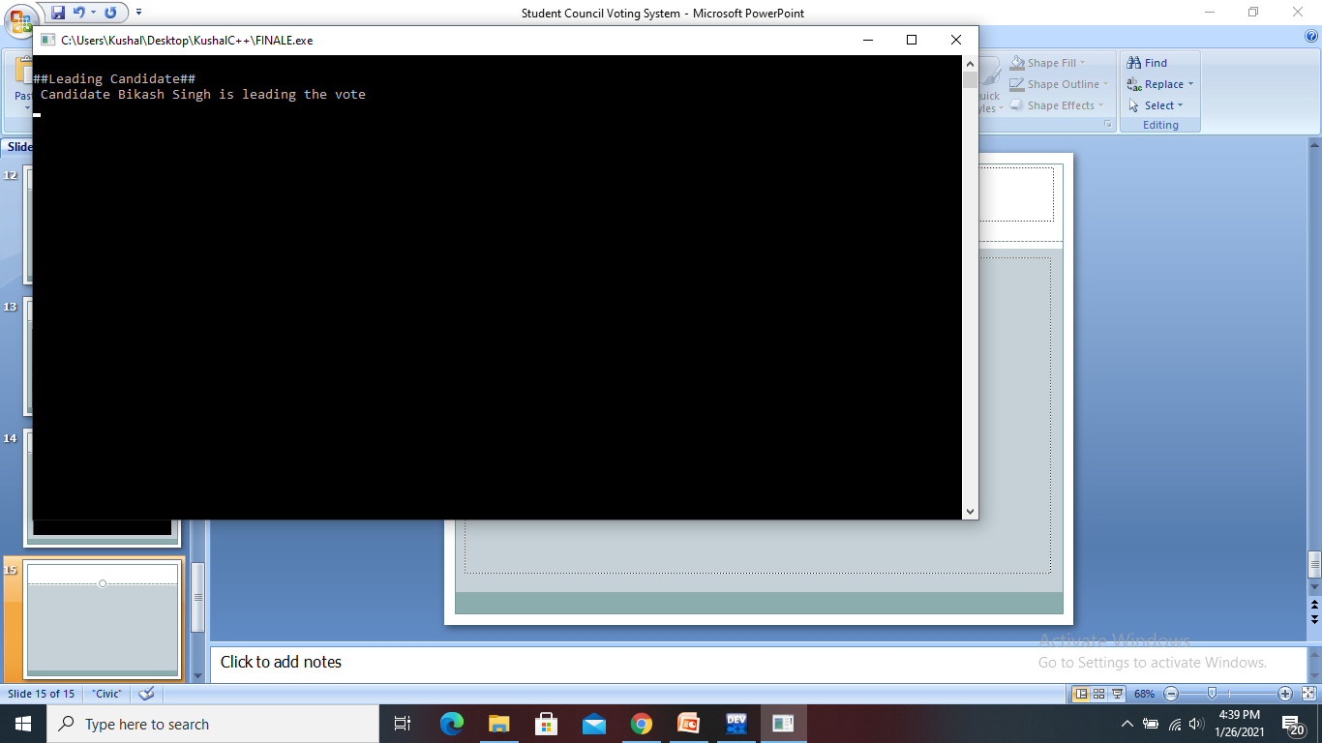

**20**

**Admin channel:**

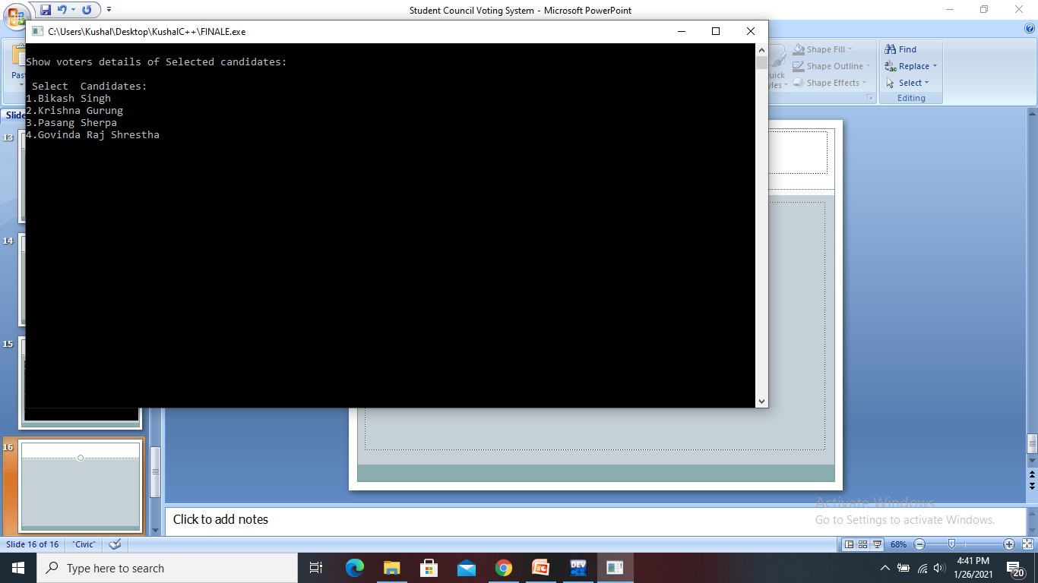

**21**

**Admin channel:**

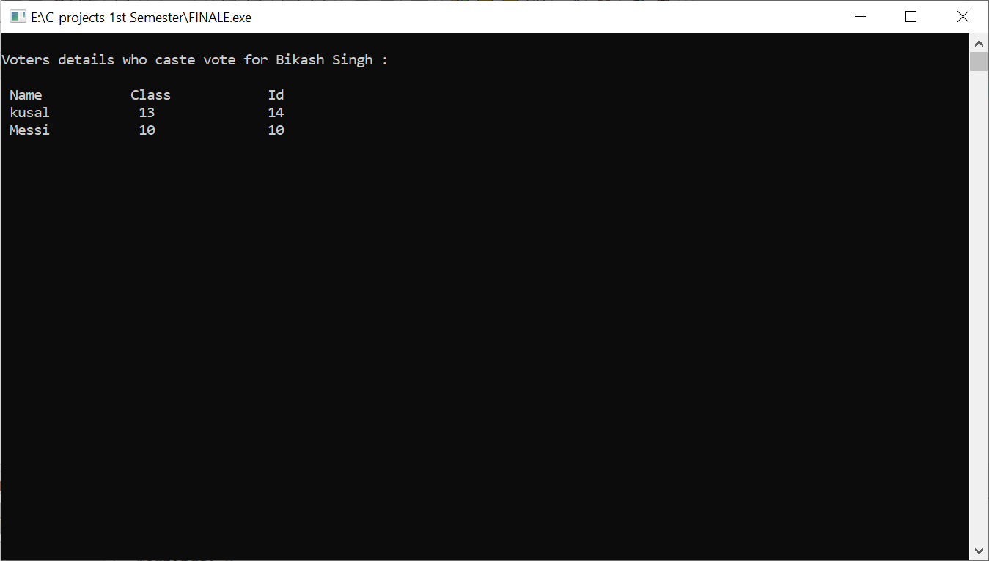

**22**

**Source Code:**

#include<stdio.h>

#include<string.h>

#include<conio.h>

#include<stdlib.h>

#define C1 "Bikash Singh"

#define C2 "Krishna Gurung"

#define C3 "Pasang Sherpa"

#define C4 "Govinda Raj Shrestha"

int votec1=0, votec2=0, votec3=0, votec4=0, i=0;

FILE *fvote,*rvote;

struct voter

{

char name[10][10];

int roll,grade,test;

} v;

void intro()

{

**23**

printf("\n\n\n\n\n\t\t\t///***********************************************************///\n");

printf("\t\t\t Welcome to the Student Council Voting for KIST College 2021\n");

printf("\t\t\t\t\t Kamalpokhari,Kathmandu\n");

printf("\t\t\t///***********************************************************///\n");

printf("\n\n\n\t\t\t\t\t Press any key to continue..........");

getch();

}

// Initiating castvote function to allow the user to choose their candidates

void castevote()

{

system("cls");

printf("Please Enter your details to cast vote: \n");

printf("Name: ");

scanf("%s",&v.name);

printf("Class: ");

scanf("%d",&v.grade);

printf("Roll No: ");

scanf("%d",&v.roll);

int candidate_chosen;

printf("\nSelect Your Candidates: \n");

**24**

printf("1.%s\n", C1);

printf("2.%s\n", C2);

printf("3.%s\n", C3);

printf("4.%s\n", C4);

//do{

printf("\nEnter your Candidates Number(1-4): ");

scanf("%d", &candidate_chosen);

v.test=candidate_chosen;

//}while(v.test<1 || v.test>4);

if(v.test == 1)

{

votec1++;

}

if(v.test == 2)

{

votec2++;

}

if(v.test == 3)

{

votec3++;

}

if(v.test == 4)

{

votec4++;

**25**

}

if(v.test>4)

{

printf("Enter the correct choice.");

}

fvote=fopen("Voter.dat","a");

fwrite(&v,sizeof(struct voter),1,fvote);

fclose(fvote);

}

//showing the user about the votes calculated

void totalvote()

{

system("cls");

printf("\nCandidate Names\t\t\t\t");

printf("Votes Count\n");

printf("1.%s\t\t\t\t\t%d\n", C1, votec1);

printf("2.%s\t\t\t\t%d\n", C2, votec2);

printf("3.%s\t\t\t\t\t%d\n", C3, votec3);

printf("4.%s\t\t\t\t%d\n", C4, votec4);

getch();

**26**

}

//display how accurate thier guess is

void guessvote()

{

system("cls");

int guessNo;

int voteArray[] = {votec1, votec2, votec3, votec4};

int temp;

int i=0,j=0;

for(i = 0; i<sizeof(voteArray)/sizeof(*voteArray); i++)

{

for(j = i + 1; j<sizeof(voteArray)/sizeof(*voteArray); j++)

{

if(voteArray[i]<voteArray[j])

{

temp = voteArray[i];

voteArray[i]=voteArray[j];

voteArray[j] = temp;

}

}

}

**27**

printf("\nGuess Who is going to Win: \n");

printf("1.%s\n", C1);

printf("2.%s\n", C2);

printf("3.%s\n", C3);

printf("4.%s\n", C4);

printf("\nEnter your Candidates Number(1-4): ");

scanf("%d", &guessNo);

switch(guessNo)

{

case 1:

if(votec1 == voteArray[0])

{

printf("\nCorrect! Mr.%s is at leading position.\n", C1);

}

else

{

printf("\nSorry! Mr.%s is not the leading candidate.\n", C1);

}

break;

case 2:

if(votec2 == voteArray[0])

{

printf("\nCorrect! Mr.%s is at leading position.\n", C2);

}

**28**

else

{

printf("\nSorry! Mr.%s is not the leading candidate.\n", C2);

}

break;

case 3:

if(votec3 == voteArray[0])

{

printf("\nCorrect! Mr.%s is at leading position.\n", C3);

}

else

{

printf("\nSorry! Mr.%s is not the leading candidate.\n", C3);

}

break;

case 4:

if(votec4 == voteArray[0])

{

printf("\nCorrect! Mr.%s is at leading position.\n", C4);

}

else

{

printf("\nSorry! Mr.%s is not the leading candidate.\n", C4);

**29**

}

break;

default:

printf("Invalid Choice");

break;

}

getch();

}

//Getting leading candidate

void leadcount()

{

system("cls");

printf("\n##Leading Candidate##\n");

if(votec1>votec2 && votec1>votec3 && votec1>votec4)

{

printf(" Candidate %s is leading the vote\n",C1);

}

else if(votec2>votec1 && votec2>votec3 && votec2>votec4)

{

printf(" Candidate %s is leading the vote\n",C2);

}

else if(votec3>votec1 && votec3>votec2 && votec3>votec4)

**30**

{

printf(" Candidate %s is leading the vote\n",C3);

}

else if(votec4>votec1 && votec4>votec2 && votec4>votec3)

{

printf(" Candidate %s is leading the vote\n",C4);

}

else

{

printf(" Non win condition\n");

}

getch();

}

void showvoter()

{

system("cls");

int j;

int x;

printf("\nShow voters details of Selected candidates:\n");

printf("\n Select Candidates: \n");

printf("1.%s\n", C1);

printf("2.%s\n", C2);

**31**

printf("3.%s\n", C3);

printf("4.%s\n", C4);

scanf("%d",&x);

//printf("%s\t %d\t %d",v.name,v.grade,v.roll);

switch(x)

{

case 1: system("cls");

printf("\nVoters details who cast vote for %s :\n",C1);

rvote=fopen("voter.dat","r");

printf("\n Name\t\tClass\t\t Id");

while(fread(&v,sizeof(v),1,rvote))

{

if(v.test==1)

{

printf("\n %s \t\t %d \t\t %d",v.name,v.grade,v.roll);

}

}

fclose(rvote);

**32**

break;

case 2: system("cls");

printf("\nVoters details who cast vote for %s :\n",C2);

rvote=fopen("voter.dat","r");

while(fread(&v,sizeof(v),1,rvote))

{

if(v.test==2)

{

printf("\n %s \t\t %d \t\t %d",v.name,v.grade,v.roll);

}

}

fclose(rvote);

break;

case 3:

system("cls");

printf("\nVoters details who cast vote for %s :\n",C3);

rvote=fopen("voter.dat","r");

while(fread(&v,sizeof(v),1,rvote))

{

**33**

if(v.test==3)

{

printf("\n %s \t\t %d \t\t %d",v.name,v.grade,v.roll);

}

}

fclose(rvote);

break;

case 4:

system("cls");

printf("\nVoters details who cast vote for %s :\n",C4);

rvote=fopen("voter.dat","r");

while(fread(&v,sizeof(v),1,rvote))

{

if(v.test==4)

{

printf("\n %s \t\t %d \t\t %d",v.name,v.grade,v.roll);

}

**34**

}

fclose(rvote);

break;

default:

printf("Enter correct choice");

break;

}

getch();

}

int main()

{

int choice;

char password[4], ch;

int p;

rvote = fopen("Voter.dat","r");

while(fread(&v,sizeof(v),1,rvote))

{

if(v.test == 1)

{

votec1++;

**35**

}

if(v.test == 2)

{

votec2++;

}

if(v.test == 3)

{

votec3++;

}

if(v.test == 4)

{

votec4++;

}

}

fclose(rvote);

intro();

while(1)

{

system("cls");

printf("\n\n\n\n\n\tChoose one among the following options(1-5)\n");

printf("\t1. Cast Your Vote!!\n");

printf("\t2. Show Total Votes Count\n");

printf("\t3. Guess who is Going to win The Voting\n");

printf("\t4. Show Leading Candidates\n");

**36**

printf("\t5. Press 5 if you are the school management\n");

printf("\t6. Exit");

printf("\n\tPlease enter your choice among(1-6): ");

scanf("%d",&choice);

switch(choice)

{

case 1:

castevote();

break;

case 2:

totalvote();

break;

case 3:

guessvote();

break;

case 4:

leadcount();

break;

case 5:

printf("\nEnter the password:: ");

for(p=0; p<4; p++)

**37**

{

ch= getch();

password[p]= ch;

ch= '*';

printf("%c", ch);

}

password[p]= '\0';

getch();

if(strcmp(password, "park")==0)

{

showvoter();

}

else

{

printf("\n Incorrect password!!!");

}

break;

case 6:

exit(1);

break;

default:

printf("\nPlease Enter the correct choice!!");

break;

}

**38**

getch();

}

return 0;

}

**39**